UNITED  NATIONS |  | EP
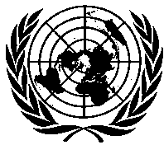 | United Nations  Environment  Programme | Distr.  GENERAL  UNEP/OzL.Pro/ExCom/85/29/Corr.1  14 May 2020  ORIGINAL: ENGLISH
EXECUTIVE COMMITTEE OF
THE MULTILATERAL FUND FOR THE
IMPLEMENTATION OF THE MONTREAL PROTOCOL
Eighty-fifth Meeting
Montreal, 25-29 May 2020
Postponed to 19-22 July 2020*

Corrigendum
PROJECT PROPOSAL: GUINEA

This document is issued to:
- In paragraph 26(a), replace “2020” with “2022”;
- In Annex I, Appendix-2A, replace:
  - “33,050” with “23,050”, and “62,600” with “52,600” in row 3.2; and
  - “278,050” with “268,050”, and “592,600” with “582,600” in row 3.3.

* Due to coronavirus disease (COVID-19)

