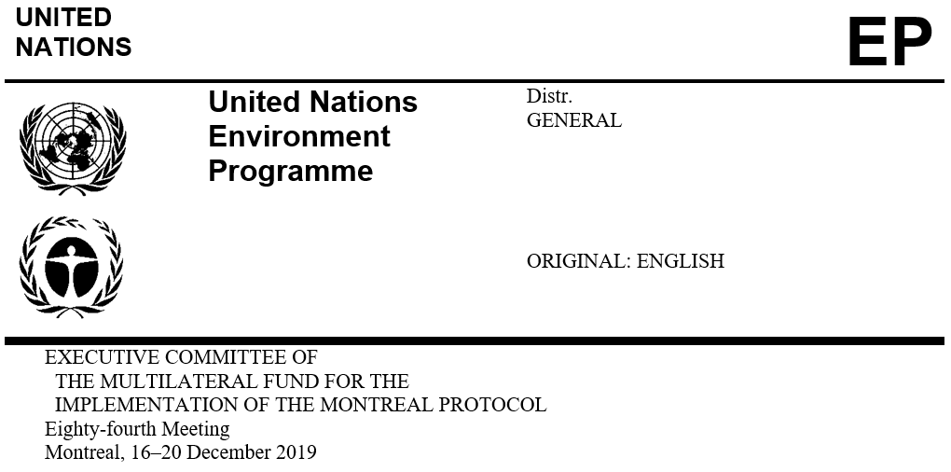

UNEP/OzL.Pro/ExCom/84/Inf.2
13 December 2019

dates AND VENUES of the 85th, 86th, 87th AND 88th MeetingS

of the executive Committee

85th and 86th meetings
- At its 83rd meeting, by decision 83/74, the Executive Committee decided:

To hold its 85th meeting from 25 to 29 May 2020 in Montreal, at a venue to be decided; and

To hold its 86th meeting during the week preceding the Thirty-Second Meeting of the Parties to the Montreal Protocol (32MOP) which was tentatively booked for 23 to 27 November 2020, at a venue to be decided.
- With regard to the 85th meeting, in the absence of availability of conference facility at the International Civil Aviation Organization (ICAO), a tentative booking has been made at La Plaza, pending a procurement process.

- With regard to the 86th meeting, the Ozone Secretariat confirmed that the venue for the 32MOP would be in Tashkent, Uzbekistan. The Government of Uzbekistan has also officially confirmed to the Secretariat its predisposition to accommodate the 86th meeting in Tashkent from 16 to 20 November 2020 and invited the Secretariat to further discuss the logistic requirement and cost differentials.

Other meetings in 2021
- The Executive Committee may wish to note the dates for the following meetings taking place in 2021:
- 43rd Meeting of the Open-ended Working Group of the Parties to the Montreal Protocol and associated meetings, from 12 to 17 July 2021, Bangkok, Thailand

- Thirty-Third Meeting of the Parties to the Montreal Protocol and associated meetings, tentatively from 30 October to 5 November 2021, at a venue to be confirmed.

Recommendation
- The Executive Committee may wish:
- To confirm holding its 86th meeting from 16 to 20 November 2020, in Tashkent, Uzbekistan, back to back with the Thirty-Second Meeting of the Parties to the Montreal Protocol;

- To hold its 87th meeting:

From 24 to 28 May 2021, in Montreal, Canada, at a venue to be determined; or

From 28 June to 2 July 2021, in Montreal, Canada, at the International Civil Aviation Organization (ICAO);
- To hold its 88th meeting:

From 15 to 19 November 2021, in Montreal, Canada, at a venue to be determined; or

From 22 to 26 November 2021 in Montreal, Canada, at the ICAO.

