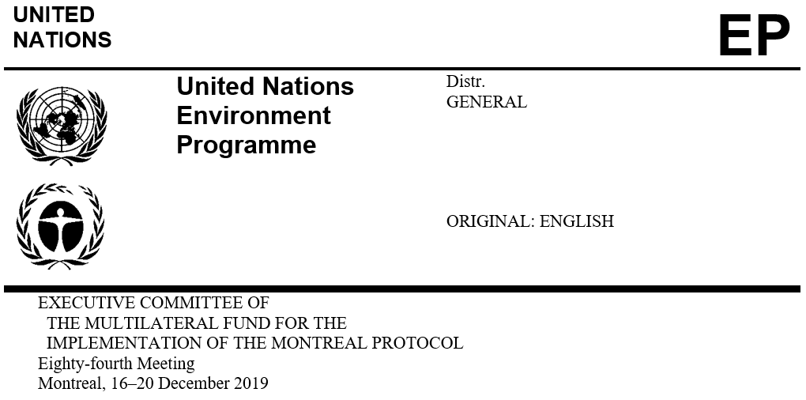

UNEP/OzL.Pro/ExCom/84/28
20 November 2019

UNDP BUSINESS PLAN FOR 2020–2022

This document presents the UNDP business plan for 2020–2022 and includes: the planned activities for the phase-out of controlled substances under the Montreal Protocol (controlled substances) during the 2020–2022 period; the business plan performance indicators; policy issues; and a recommendation for consideration by the Executive Committee. The narrative of UNDP’s business plan for 2020–2022 is attached to the present document.
Planned activities during 2020–2022

Table 1 sets out, by year, the value of activities included in UNDP’s business plan.
Table 1. Resource allocation in the UNDP business plan for 2020–2022 as submitted (US $000s)*
 | 2020 | 2021 | 2022 | Total  (2020–2022) | Total after 2022
HCFC activities
Approved HCFC phase-out management plans (HPMPs) | 48,971 | 31,394 | 38,467 | 118,832 | 2,571
HPMP project preparation (PRP) – stage II | 10 | 0 | 0 | 10 | 0
HPMP stage II | 1,691 | 2,153 | 136 | 3,981 | 3,915
HPMP PRP – stage III | 789 | 415 | 182 | 1,386 | 0
HPMP stage III | 1,127 | 912 | 949 | 2,988 | 5,075
HCFC activities subtotal | 52,589 | 34,874 | 39,734 | 127,197 | 11,561
HFC activities
HFC – enabling activities | 102 | 0 | 0 | 0 | 0
HFC phase-down plan – PRP | 1,768 | 1,286 | 478 | 3,533 | 0
HFC phase-down plan | 0 | 0 | 7,290 | 7,290 | 0
HFC activities subtotal | 1,870 | 1,286 | 7,768 | 10,823 | 0
Standard activities
Institutional strengthening (IS) | 2,931 | 3,456 | 2,931 | 9,317 | 0
Core unit | 2,113 | 2,128 | 2,143 | 6,384 | 0
Standard activities subtotal | 5,044 | 5,584 | 5,073 | 15,701 | 0
Grand total | 59,502 | 41,744 | 52,576 | 153,721 | 11,561
* Including agency support costs where applicable.

Secretariat’s comments

Stage II of HPMPs

The total levels of funding for stage II of HPMPs in low-volume-consuming (LVC) countries to meet the 67.5 per cent reduction of the HCFC baseline amount to US $4.98 million (including US $2.93 million for 2020–2022), and to meet a 100 per cent reduction amount to US $868,743 (including US $526,820 for 2020–2022).

The funding distribution of stage II of HPMPs for non-LVC countries by sector is provided in Table 2.
Table 2. Funding distribution of stage II of HPMPs in non-LVC countries by sector (US $000)
Sector | 2020–2022 | After 2022 | Total | Per cent of total (%)
Refrigeration servicing | 522 | 1,527 | 2,049 | 100.0
Total | 522 | 1,527 | 2,049 | 100.0

Stage III of HPMPs

The total of US $8.06 million is included in the business plan for stage III of HPMPs for six countries (the Dominican Republic, Lebanon, Nigeria, Panama, the Republic of Moldova and Uruguay) (including US $2.99 million for 2020–2022). Inclusion of stage III of HPMPs in the business plan is allowed only for those countries that had stage II of an HPMP approved to meet a reduction target by 2020 (decision 82/45(c)(i)). Two of these countries have an approved stage II with reduction target beyond 2020 (Lebanon and Nigeria).
HFC-related activities

HFC activities include an enabling activity (US $101,650 in 2020 for Belize); HFC phase-down preparation activities for 19 countries amounting to US $3.53 million in 2020–2022; and HFC phase-down management plan activities for seven countries amounting to US $7.29 million in 2020–2022.

For the enabling activity, Belize has submitted the required letter from the Government indicating its intent to make best efforts to ratify the Kigali Amendment as early as possible, in line with decision 79/46(d)(i).

With regard to the preparation activities, funding for the preparation of national implementation plans to meet initial reduction obligations for the phase-down of HFCs could be provided, at the earliest, five years prior to those obligations, after a country had ratified the Kigali Amendment and on the basis of guidelines to be approved in the future (decision 79/46(b)(iii)). Of the 19 countries, seven countries have not ratified the Kigali Amendment (Bangladesh, Fiji, Indonesia, Iran (Islamic Republic of), Kyrgyzstan, Lebanon and Turkey). One of the seven countries has not submitted the required letter from the Government indicating its intent to make best efforts to ratify the Kigali Amendment.

HFC phase-down management plan activities are included in the business plan for Costa Rica, Cuba, Ghana, Grenada, Nigeria, Panama and Viet Nam. However, there is no decision from the Executive Committee allowing countries to submit HFC phase-down management plan as only the preparatory funding is eligible according to decision 79/46(b)(iii).
Core unit costs

The core unit costs are expected to increase at an annual rate of 0.7 per cent as agreed.
Proposed adjustments by the Secretariat

During the IACM, adjustments to the business plans of bilateral and implementing agencies were agreed based on relevant decisions of the Executive Committee. In reviewing the revised UNDP business plan for 2020–2022, the Secretariat noted that the following adjustments were not included:
Table 3. Adjustments to the UNDP business plan for 2020–2022 (US $000)
Adjustment | 2020–2022 | After 2022
HPMP values to reflect the actual amounts approved under the Agreements or revised Agreement submitted to the 84th meeting | (11,878) | 12,812
Stage II of HPMP values to reflect the Agreement submitted to the 84th meeting | (312) | 453
Stage II of HPMPs in LVC countries to the maximum allowable value to meet the 67.5 per cent reduction of the HCFC baseline based on decision 74/50(c)(xii) | (4) | (6)
PRP for stage III of HPMPs pursuant to decision 71/42 | (260) | 225
Stage III of HPMPs pursuant to decision 82/45(c)(i) | (1,674) | (3,385)
PRP for HFC phase-down pursuant to decision 56/16(c) or countries that have not ratified the Kigali Amendment | (2,152) | 0
HFC phase-down management plan pursuant to decision 79/46(b)(iii) | (7,290) | 0

Table 4 presents the results of the Secretariat’s proposed adjustments to the UNDP business plan for 2020–2022, which are also addressed in the context of the Consolidated business plan of the Multilateral Fund for 2020–2022.
Table 4. Resource allocation in UNDP’s adjusted business plan for 2020–2022 (US $000s)*
 | 2020 | 2021 | 2022 | Total (2020–2022) | Total after 2022
HCFC activities
Approved HPMPs | 57,822 | 29,437 | 19,695 | 106,954 | 15,383
HPMP PRP – stage II | 10 | 0 | 0 | 10 | 0
HPMP stage II | 1,689 | 1,839 | 136 | 3,665 | 4,363
HPMP PRP – stage III | 529 | 415 | 182 | 1,126 | 225
HPMP stage III | 1,127 | 75 | 112 | 1,314 | 1,690
HCFC activities subtotal | 61,178 | 31,766 | 20,125 | 113,069 | 21,660
HFC activities
HFC – enabling activities | 102 | 0 | 0 | 0 | 0
HFC phase-down plan – PRP | 922 | 459 | 0 | 1,381 | 0
HFC phase-down plan | 0 | 0 | 0 | 0 | 0
HFC activities subtotal | 1,024 | 459 | 0 | 1,381 | 0
Standard activities
IS | 2,931 | 3,456 | 2,931 | 9,317 | 0
Core unit | 2,113 | 2,128 | 2,143 | 6,384 | 0
Standard activities subtotal | 5,044 | 5,584 | 5,073 | 15,701 | 0
Grand total | 67,245 | 37,809 | 25,198 | 130,151 | 21,660
* Including agency support costs where applicable.

Performance indicators

UNDP submitted performance indicators pursuant to decision 71/28 in its business plan narrative. The Secretariat informed UNDP of the targets shown in Table 5.
Table 5. Performance indicators for UNDP for 2020
Type of indicator | Short title | Calculation | 2020 target
Planning--Approval | Tranches approved | Number of tranches approved vs. those planned* | 42
Planning--Approval | Projects/activities approved | Number of projects/activities approved vs. those planned (including project preparation activities)** | 24
Implementation | Funds disbursed | Based on estimated disbursement in progress report | US $15,618,655
Implementation | ODS phase-out | ODS phase-out for the tranche when the next tranche is approved vs. those planned per business plans | 570.2 ODP tonnes
Implementation | Project completion for activities | Project completion vs. planned in progress reports for all activities (excluding project preparation) | 70
Administrative | Speed of financial completion | The extent to which projects are financially completed 12 months after project completion | 70%
Administrative | Timely submission of project completion reports | Timely submission of project completion reports vs. those agreed | 3
Administrative | Timely submission of progress reports | Timely submission of progress reports and business plans and responses unless otherwise agreed | On time
* The target of an agency would be reduced if it could not submit a tranche owing to another cooperating or lead agency, if agreed by that agency.
** Project preparation should not be assessed if the Executive Committee has not taken a decision on its funding.

Policy issues

UNDP presents the following policy issues related to the cost guidelines for HFC phase-down under consideration by the Executive Committee, which were presented during the IACM:

Consider funding the market transformation by using the incremental operating cost in a more flexible and inclusive manner, rather than bundled with specific eligible industries;

Challenges of LVC countries in terms of the demonstration of alternative technologies and ability to scale up with limited funding available;

The assembly sub-sector in the servicing sector should be paid special attention and separated from other activities in the servicing sector with different treatment; and

In the context of the Kigali Amendment, cost-effectiveness based on CO₂-equivalent should be taken into account, and the communication and synergy with the broader climate actions on the national and international levels are necessary.
RECOMMENDATION

The Executive Committee may wish:

To note the UNDP business plan for 2020–2022, contained in document UNEP/OzL.Pro/ExCom/84/28; and

To approve the performance indicators for UNDP as set out in Table 5 of document UNEP/OzL.Pro/ExCom/84/28.

A draft business plan for 2020–2022 of UNDP was discussed at the Inter-agency coordination meeting (IACM) held in Montreal from 9 to 11 October 2019. The business plan contained in this document has addressed the issues raised at the meeting.
UNDP’s 2020 core unit cost request has been submitted to the 84th meeting (UNEP/OzL.Pro/ExCom/84/38).
UNEP/OzL.Pro/ExCom/84/26

