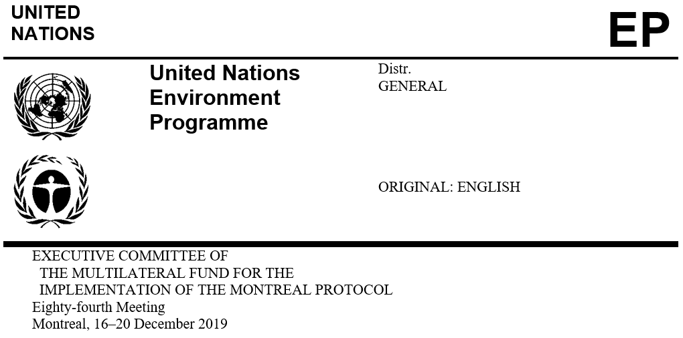

UNEP/OzL.Pro/ExCom/84/22/Add.3
13 December 2019

Addendum

REPORT ON THE PRODUCTION OF CARBON TETRACHLORIDE AND ITS FEEDSTOCK USES IN CHINA (DECISION 75/18 (b) (iii))

This document is being issued to provide information received subsequent to the issuance of document UNEP/OzL.Pro/ExCom/84/22/Add.2 as follows:

- Add the following paragraph after paragraph 25

Summary

25(bis). Approximately two thirds of the CTC generated is converted in the CM production facilities to six non-ODS bulk chemicals: methyl chloride or hydrochloric acid (HCl), perchloroethylene (PCE), and chloroform; and minor quantities converted to HFC-245fa and HFC-365mfc. The conversion to PCE accounts for over half of the CTC converted by the CM producers, with methyl chloride or HCl accounting for a further 28 per cent and chloroform accounting for 16 per cent. The remaining approximately one third of the CTC generated is used as a feedstock by 21 registered feedstock users for the production of 11 non-ODS chemicals, with two chemicals— PCE and HFC-245fa—accounting for approximately 70 per cent of that use. CTC is also used as a process agent and for laboratory and analytical uses that are given exemptions. Those uses accounted for less than 0.5 per cent of the CTC used in China.

- Add the following paragraphs after paragraph 31

31(bis). The World Bank inter alia clarified:

  - The Government requires feedstock producers and users to report their production and consumption to FECO on a quarterly basis. CM producers cannot sell CTC to non-registered feedstock users. Feedstock users are not allowed to sell CTC and can only use it for the use for which they were registered and that is specified in their environmental impact assessment (EIA);

  - All CM producers have to be registered with FECO;

  - Only three CMs producers are allowed to sell CTC for feedstock uses as they were part of the original producers covered by the CTC phase-out and historically sold CTC for feedstock uses prior to 2010;

  - All CM producers must have conversion facilities to convert the CTC by-produced to other products, destroy excess CTC, or send the excess CTC to an accredited waste management facility for disposal. CMs producers are required to report the amount of residue produced, disposed, and stored to local Ecology and Environment Bureaus (EEBs);

  - There are no specific requirements for CTC emissions but for volatile organic hydrocarbons (VOCs), which includes CTC, a known carcinogen. Accordingly, enterprises, including the CM production facilities, do not monitor CTC emissions directly; rather, emissions of VOCs are monitored, including by local EEBs. There are no norms for levels of CTC emissions for storage, transport and handling of CTC;

  - Feedstock users submit an EIA, and information on the CTC used and final products manufactured, as part of the annual registration process. CM producers that convert CTC have to follow the same process and must provide information on CTC used to FECO on a quarterly basis;

  - There are eight dealers registered with FECO that are allowed to sell CTC to registered feedstock users and among themselves. Sales are reported to FECO; and

  - Notwithstanding the increased production of HFC-245fa, HFC-365mfc and HFC-236fa between 2015 and 2017, there is substantial spare capacity for those chemicals in China. All three production processes are liquid-phase reactions.

- Add the following sentence at the end of paragraph 32

The Government considers the existing monitoring system, which does not use material use ratios due to the complexity of the industry in China, adequate.
- Add the following paragraph after paragraph 36

36(bis). The Secretariat also noted that an additional scientific report published on resolving the budget discrepancy of CTC emissions from China in Atmospheric Chemistry and Physics in August 2018^{(bis)} suggested that approximately 89 per cent of the CTC enhancements observed in that study are related to CTC emissions from the production on methyl chloride, methylene chloride, chloroform, and PCE and its use as a feedstock and process agent in chemical manufacturing industries.

- Add the following paragraphs after paragraph 37

37(bis). The World Bank clarified that while the acetylene chlorination route is the preferred technology in China to produce PCE, one PCE producer and eight CM producers, one of which is also a registered CTC feedstock user, use the alkane chlorination route. The PCE producer that uses the alkane chlorination route is neither a registered CTC producer or user as CTC is produced and used in a closed loop.

37(ter). The Government is considering to require PCE producers that produce CTC as an intermediate product to register in the future. This new requirement would only apply to PCE producers that use the C1-C3 alkane chlorination route, and would not apply to producers that use the acetylene chlorination method as no CTC is used or generated in that process. CM producers that use the C1-C3 alkane chlorination route are already required to register and provide quarterly data to FECO, including both the quantity of CTC used and the quantity of PCE produced.

^{(bis)} Park S., Li S., Mühle J, O'Doherty S, Weiss RF, Fang X., Reimann S., Prinn RG. (2018): Toward resolving the budget discrepancy of ozone-depleting carbon tetrachloride (CCl4): an analysis of top-down emissions from China. Atmospheric Chemistry and Physics, 18. https://doi.org/10.5194/acp-18-11729-2018

