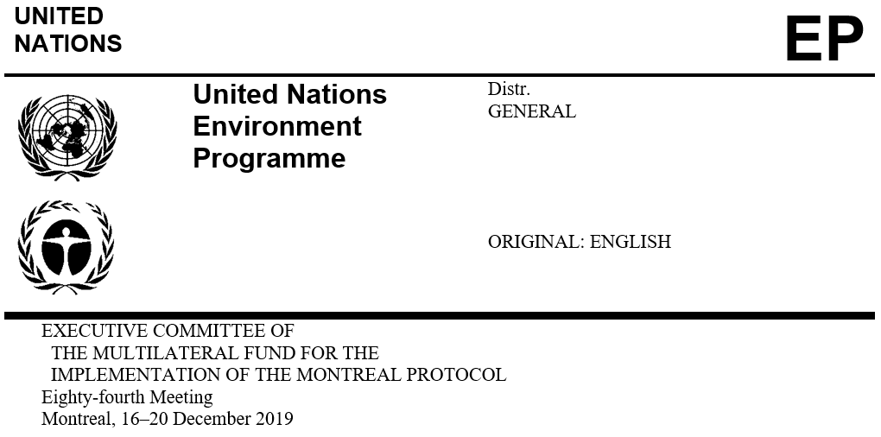

UNEP/OzL.Pro/ExCom/84/6
26 November 2019

FINAL 2018 ACCOUNTS

Introduction

This document presents the final accounts of the Multilateral Fund (MLF) for the year ended 31 December 2018. In addition, in response to decision 83/4(b), a separate certified statement of income and disbursements of the additional contributions for the fast-start support for the implementation of the HFC phase-down is included.

Annex I to the present document consists of the following schedules:

Schedule 1.1: The statement of revenue and expenses

Appendix of Schedule 1.1: Certified statement of income and disbursements of the additional

contributions for fast-start support for the implementation of HFC phase-down

Schedule 1.2: 2018 Statement of financial position

Schedule 1.3: 2018 MLF Secretariat expenses

Schedule 1.4: Sub-accounts of UNDP managed activities 1991-2018

Schedule 1.5: Sub-accounts of UNEP managed activities 1991-2018

Schedule 1.6: Sub-accounts of UNIDO managed activities 1991-2018

Schedule 1.7: Sub-accounts of the World Bank managed activities 1991-2018

Schedule 1.1 provides information on the agreed contributions under the revenue category and shows that the fixed-exchange-rate-mechanism (FERM) gain was US $1,879,766 in 2018 compared to a loss of US $15,507,000 in 2017. This is attributed to the United States dollar exchange rates in 2018 compared to other currencies. This schedule also provides the aggregated data on the Secretariat and the implementing agencies’ (IAs) expenses; and the net Fund balance as at the end of 2018.

Appendix of schedule 1.1 is provided as a follow-up to decision 83/4(b). It reflects an unused balance of US $13,698 which will be added to the regular pledged contributions to the Multilateral Fund.

Schedule 1.2 presents the status of voluntary pledges receivable which amounted to US $10,560,860. This is after reducing total aggregate receivables of US $192,651,963, by US $182,091,103, representing doubtful accounts in line with the International Public Sector Accounting Standards (IPSAS).

Schedule 1.3 presents actual expenses charged against the Secretariat budget in 2018 as approved by decision 80/5(b)(i). Although the unspent balance is US $1,743,969, the return to the Multilateral Fund at the 84th meeting is US $1,646,463, consisting of US $1,624,548 from the Secretariat’s budget and US $21,915 from the Monitoring and Evaluation budget. The amount of US $97,506 not returned to the Fund consists of 2018 expenditures to be recorded in 2019.

Schedules 1.4 to 1.7 contain the final accounts of the IAs submitted to the Treasurer by the end of September 2019. Since the IAs’ final accounts were submitted after UNEP 2018 accounts were closed, only the provisional accounts submitted by the IAs in January 2019 were recorded in the UNEP final accounts. Table 1 provides the difference between IAs’ provisional and final 2018 accounts on aggregate revenue and expenses and shall be recorded in the 2019 accounts.
Table 1. Differences between provisional and final 2018 accounts on aggregate income and expenditure (US $)
Agency | Provisional |  | Final |  | Difference
Revenue
UNDP | 907,188,989 |  | 939,609,957 |  | 32,420,968
UNEP | 351,124,435 |  | 351,434,682 |  | 310,247
UNIDO | 934,192,374 |  | 934,192,374
World Bank | 1,291,222,683 |  | 1,291,222,683
Expenses
UNDP |  | 846,848,840 |  | 849,819,008 | 2,970,168
UNEP |  | 291,320,463 |  | 292,878,761 | 1,558,298
UNIDO |  | 811,470,932 |  | 810,485,357 | (985,575)
World Bank |  | 1,237,741,650 |  | 1,237,741,650

Report of the United Nations Board of Auditors (UNBoA) on the financial statements of the Fund for the year ended 31 December 2018

The report of the UNBoA on the accounts of the Fund for the year ended 31 December 2018 (A/74/5/Add.7). has been finalised and submitted to the UNEP Executive Director. The report included a section on the MLF financial statements. The UNEP audit report is unqualified and none of the audit observations pertain to the Multilateral Fund.
Recommendation

The Executive Committee may wish:

To note the final audited financial statements of the Multilateral Fund as at 31 December 2018 prepared in accordance with the International Public Sector Accounting Standards, and the certified statement of income and disbursements of the additional contributions for fast-start support for the implementation of HFC phase-down pursuant to decision 83/4(b) as contained in document UNEP/OzL.Pro/ExCom/84/6; and

To request The Treasurer to record in the 2019 accounts of the Multilateral Fund, the differences between the implementing agencies’ provisional 2018 financial statements and their final 2018 statements as reflected in Table 1 of the document UNEP/OzL.Pro/ExCom/84/6.

The Treasurer was requested to submit to the 84th meeting, as part of the 2018 accounts of the Multilateral Fund, a certified statement of income and disbursements of the additional contributions for fast-start support for the implementation of HFC phase-down separately from the regular contributions to the Multilateral Fund.
This issue is discussed in document UNEP/OzL.Pro/ExCom/84/5
http://undocs.org/en/A/74/5/Add.7

