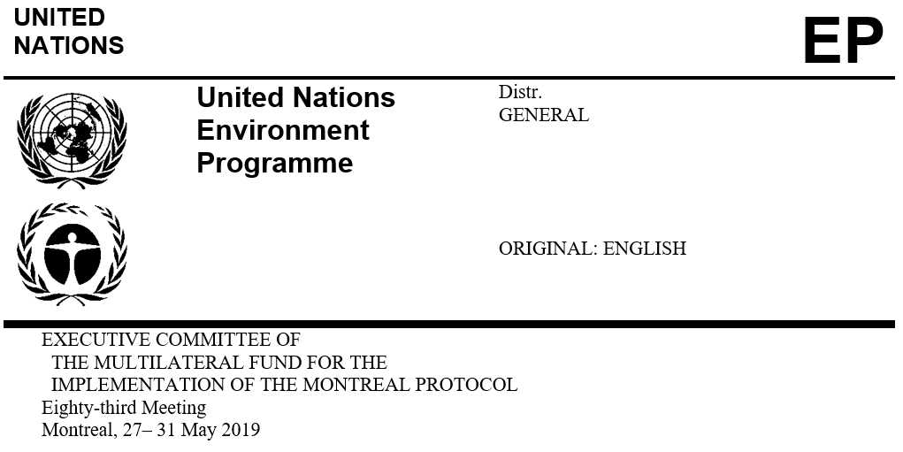

UNEP/OzL.Pro/ExCom/83/48/Corr.3
21 June 2021

Corrigendum

REPORT OF THE EIGHTY-THIRD MEETING OF THE EXECUTIVE COMMITTEE

This document is being issued to:
- Replace, in Annex X, Appendix-2A:
  - “43.33” and “41.08” with “33.38” in row 1.1 and row 1.2, respectively, for 2020;
  - “2.57” with “12.50” in row 4.1.1;
  - “43.31” with “33.38” in row 4.1.3; and
  - “8.10” with “7.90” in row 4.3.3.

