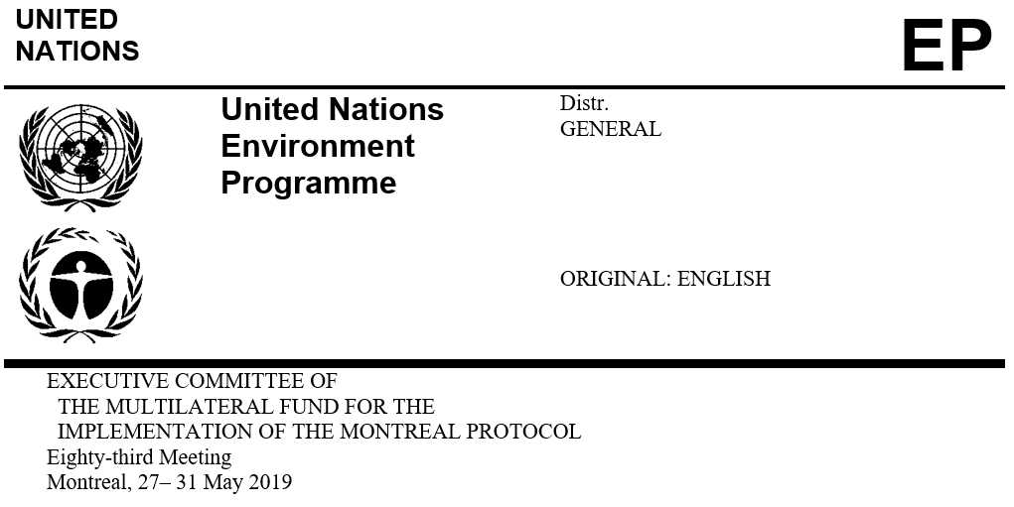
UNEP/OzL.Pro/ExCom/83/30
29 April 2019

PROJECT PROPOSAL: MALI

This document consists of the comments and recommendation of the Secretariat on the following project proposal:

Phase-out

- HCFC phase-out management plan (stage I, fourth tranche) | UNEP and UNDP

PROJECT EVALUATION SHEET – MULTI-YEAR PROJECTS

Mali

(I) PROJECT TITLE | AGENCY | MEETING APPROVED | CONTROL MEASURE
HCFC phase out plan (Stage I) | UNDP, UNEP (lead) | 63rd | 35% by 2020

(II) LATEST ARTICLE 7 DATA (Annex C Group l) | Year: 2018 | 9.08 (ODP tonnes)

(III) LATEST COUNTRY PROGRAMME SECTORAL DATA (ODP tonnes) |  |  |  |  |  |  |  | Year: 2018
Chemical | Aerosol | Foam | Fire fighting | Refrigeration |  | Solvent | Process agent | Lab use | Total sector consumption
 |  |  |  | Manufacturing | Servicing
HCFC-22 |  |  |  |  | 9.08 |  |  |  | 9.08

(IV) CONSUMPTION DATA (ODP tonnes)
2009 - 2010 baseline: | 15.00 | Starting point for sustained aggregate reductions: | 15.00
CONSUMPTION ELIGIBLE FOR FUNDING (ODP tonnes)
Already approved: | 5.20 | Remaining: | 9.80

(V) BUSINESS PLAN |  | 2019 | 2020 | Total
UNDP | ODS phase-out (ODP tonnes) | 0.00 | 0.26 | 0.26
 | Funding (US $) | 0 | 30,100 | 30,100
UNEP | ODS phase-out (ODP tonnes) | 0.48 | 0.26 | 0.74
 | Funding (US $) | 58,760 | 31,640 | 90,400

(VI) PROJECT DATA |  |  | 2011 | 2012 | 2013 | 2014 | 2015 | 2016 | 2017 | 2018* | 2019 | 2020 | Total
Montreal Protocol consumption limits |  |  | n/a | n/a | 15.0 | 15.0 | 13.5 | 13.5 | 13.5 | 13.5 | 13.5 | 9.8 | n/a
Maximum allowable consumption (ODP tonnes) |  |  | n/a | n/a | 15.0 | 15.0 | 13.5 | 13.5 | 13.5 | 13.5 | 13.5 | 9.8 | n/a
Agreed funding (US$) | UNDP | Project costs | 160,000 | 0 | 0 | 0 | 0 | 92,000 | 0 | 0 | 0 | 28,000 | 280,000
 |  | Support costs | 12,000 | 0 | 0 | 0 | 0 | 6,900 | 0 | 0 | 0 | 2,100 | 21,000
 | UNEP | Project costs | 65,000 | 0 | 55,000 | 0 | 0 | 80,000 | 0 | 52,000 | 0 | 28,000 | 280,000
 |  | Support costs | 8,450 | 0 | 7,150 | 0 | 0 | 10,400 | 0 | 6,760 | 0 | 3,640 | 36,400
Funds approved by ExCom (US$) |  | Project costs | 225,000 | 0 | 55,000 | 0 | 0 | 172,000 | 0 | 0 | 0.0 | 0.0 | 452,000
 |  | Support costs | 20,450 | 0 | 7,150 | 0 | 0 | 17,300 | 0 | 0 | 0.0 | 0.0 | 44,900
Total funds requested for approval at this meeting (US$) |  | Project costs | 0 | 0 |  | 0 | 0 | 0 | 0 | 0 | 52,000* | 0 | 0
 |  | Support costs | 0 | 0 |  | 0 | 0 | 0 | 0 | 0 | 6,760 | 0 | 0
* The fourth tranche should have been submitted in 2018.

Secretariat's recommendation: | Blanket approval

PROJECT DESCRIPTION

On behalf of the Government of Mali, UNEP as the lead implementing agency, has submitted a request for funding for the fourth tranche of stage I of the HCFC phase-out management plan (HPMP), at the amount of US $52,000, plus agency support costs of US $6,760 for UNEP only. The submission includes a progress report on the implementation of the third tranche and the tranche implementation plan for 2019 to 2020.
Report on HCFC consumption

The Government of Mali reported a consumption of 9.08 ODP tonnes of HCFC in 2018, which is over 39 per cent below the HCFC baseline for compliance. The 2014-2018 HCFC consumption is shown in Table 1.
Table 1. HCFC consumption in Mali (2014-2018 Article 7 data)
HCFC-22 | 2014 | 2015 | 2016 | 2017 | 2018 | Baseline
Metric tonnes | 185.09 | 184.00 | 175.09 | 165.09 | 165.00 | 272.30
ODP tonnes | 10.18 | 10.12 | 9.63 | 9.08 | 9.08 | 15.00

Mali has import of HCFC-22 only and this substance is used in servicing existing refrigeration and air-conditioning applications. The consumption of HCFC-22 is decreasing due to decreasing population of HCFC-22-based equipment, implementation of the HPMP through regulatory controls and training and capacity building of service technicians on good service practices, and increasing adoption of HCFC-free alternatives mainly in air-conditioning applications. There is no reported use of ODS except HCFCs in the market.
Country programme (CP) implementation report

The Government of Mali reported HCFC sector consumption data under the 2018 CP implementation report which is consistent with the data reported under Article 7 of the Montreal Protocol.
Progress report on the implementation of the third tranche of the HPMP

Legal framework

The Government of Mali has an operational import/export licensing and quota system in place of ODS including HCFCs. The Decree of 22 January 2007 regulates the import, trade, use and re-export of ODS including HCFCs and HCFC-based equipment. The Government has continued to strengthen regulatory controls by regular inspections in local markets to identify instances of illegal consignments, training of customs and Ministry of Trade officers, and awareness activities focusing on ODS regulations among importers, shipping companies, customs brokers, retailers and service companies. The Government continues to implement regulations prohibiting import of ODS and equipment using ODS other than HCFCs.
Refrigeration servicing sector

The main activities implemented include:

Five workshops to train a total of 175 customs and environment officers and other enforcement agents in monitoring and controlling the import and distribution of HCFCs. The curriculum of the customs training school is being revised to include training manual on ODS regulations and import and export of ODS;

Six workshops to train a total of 255 refrigeration technicians on good practices in servicing air-conditioning equipment including the recovery and recycling of HCFCs and safe handling of hydrocarbon-refrigerants;

Procurement and delivery of equipment and tools to four training centers and selected workshops in the districts of Bamako (3) and Segou (1). The equipment include refrigerant identifiers, portable electronic leak detectors, vacuum pumps, gauges, recovery and recycling units, and recovery cylinder, safety kits and accessories; and

Activities under end-user sub-component for commercial refrigeration were postponed as low-global warming potential (GWP) technologies (e.g., hydrocarbons (HC)) for retrofit of equipment are not available. The funds allocated for this component (US $10,000) were used for providing equipment support for training centers.
Project implementation and monitoring unit (PMU)

PMU plays a role in project implementation monitoring. The PMU funds were used for recruitment of consultants to assess the implementation of the HPMP and make recommendations to improve effectiveness. The consultants submitted two annual reports to the national ozone unit (NOU).
Level of fund disbursement

As of March 2019, of the US $448,830 approved so far, US $434,723 had been disbursed (US $196,830 for UNEP and US $237,893 for UNDP) as shown in Table 2. The balance of US $14,107 will be disbursed by the year 2020.
Table 2. Financial report of stage I of the HPMP for Mali (US $)
Agency | First tranche |  | Second tranche |  | Third tranche |  | Total
 | Approved | Disbursed | Approved | Disbursed | Approved | Disbursed | Approved | Disbursed
UNEP | 61,830* | 61,830 | 55,000 | 55,000 | 80,000 | 80,000 | 196,830 | 196,830
UNDP | 160,000 | 160,000 | 0 | 0 | 92,000 | 77,893 | 252,000 | 237,893
Total | 221,830 | 221,830 | 55,000 | 55,000 | 172,000 | 157,893 | 448,830 | 434,723
Disbursement rate % | 100.0 |  | 100.0 |  | 92.0 |  | 97.0
* US $65,000 was approved; US $3,170 was returned at the 73rd meeting.

Implementation plan for the fourth tranche of the HPMP

The following activities will be implemented between March 2019 and June 2020:

Training of 80 customs and environment officers and other enforcement agents on the identification and control of HCFC and HCFC-based equipment as well as enforcement of the quota system (UNEP) (US $20,000);

Training of 100 refrigeration technicians on good practices in servicing air-conditioning equipment including the recovery and recycling of HCFCs and safe handling of hydrocarbon refrigerants (UNEP) (US $22,000); and

Monitoring the implementation of the HPMP activities (UNEP) (US $10,000).

SECRETARIAT’S COMMENTS AND RECOMMENDATION

COMMENTS

Progress report on the implementation of the third tranche of the HPMP

Legal framework

The Government of Mali has already issued HCFC import quotas for 2019 at 8.25 ODP tonnes, which is about 39 per cent lower than the Montreal Protocol control targets.
Refrigeration servicing sector

UNEP indicated that due to the political situation in the country, the implementation of activities of the previous tranche had been delayed. The delays have now been resolved and in cooperation with the NOU, implementation of activities has been expedited.

UNEP clarified that availability of low-GWP alternatives such as R-290 and R-32 is limited. As to the retrofitting activities in air-conditioning applications from HCFC-22 to R-290, UNEP reported that the Government of Mali is fully aware of the relevant decisions of the Executive Committee on retrofitting. The training programmes cover safe use of flammable refrigerants but do not encourage retrofitting of HCFC-based equipment with flammable alternatives.

With regard to the long-term sustainability of the HPMP activities, UNEP mentioned that customs and enforcement officers are trained on an ongoing basis on ozone issues through the customs training school. Regarding the servicing sector, training programmes for technicians will continue to be implemented on good practices and safe use of alternative refrigerants, coupled with capacity building of training centers through equipment support; by implementing these activities in close cooperation with service associations, sustainability of these programmes would be ensured.
Conclusion

The implementation of the HPMP is progressing despite the challenging political situation in the country. The level of fund disbursed is 97 per cent. Based on the Article 7 data for 2018, Mali is in compliance with the Montreal Protocol and its Agreement with the Executive Committee. Mali continues to implement training of service technicians and enforcement officers and awareness raising activities, and has taken steps to build capacity of technical institutions through equipment support and work closely with the refrigeration association for sustainable implementation of HCFC phase-out activities. The end-user incentive programme that was originally proposed to be implemented for retrofit of commercial refrigeration equipment would not be implemented and the funds for this programme are being used for equipment support to training institutions. During the fourth tranche, the Government will continue to strengthen the capacity of service technicians and enforcement officers for sustaining the HCFC phase-out.
RECOMMENDATION

The Fund Secretariat recommends that the Executive Committee takes note of the progress report on the implementation of the third tranche of stage I of the HCFC phase-out management plan of (HPMP) for Mali; and further recommends blanket approval of the fourth tranche of stage I of the HPMP for Mali, and the corresponding 2019-2020 tranche implementation plan, at the funding level shown in the table below, on the understanding that if Mali were to decide to proceed with retrofits and associated servicing to flammable and toxic refrigerants in refrigeration and air-conditioning equipment originally designed for non-flammable substances, it would do so assuming all associated responsibilities and risks and only in accordance with the relevant standards and protocols:
 | Project title | Project funding (US $) | Support cost (US $) | Implementing agency
(a) | HCFC phase-out management plan (stage I, fourth tranche) | 52,000 | 6,760 | UNEP

As per the letter of 18 March 2019 from the Ministère de l’Environnement, de l’Assainissement et du Développement Durable of Mali to the Secretariat.
Decisions 72/17 and 73/34.

