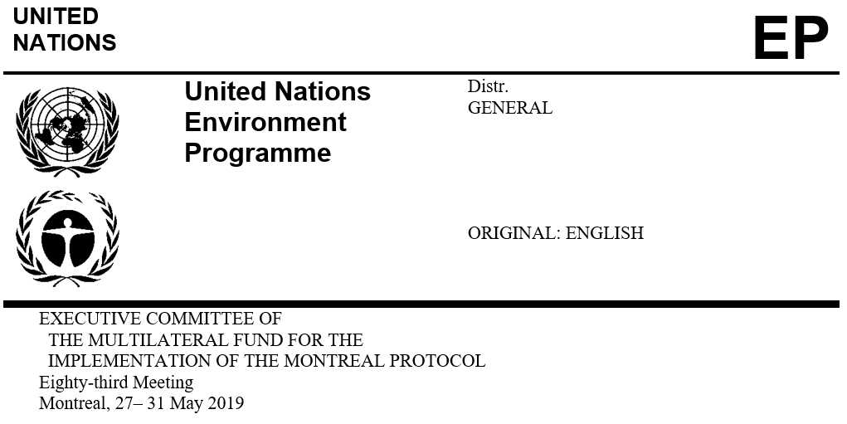
UNEP/OzL.Pro/ExCom/83/20
2 May 2019

PROJECT PROPOSAL: ARMENIA

This document consists of the comments and recommendation of the Secretariat on the following project proposal:

Phase-out

- HCFC phase-out management plan (stage II, second tranche) | UNDP and UNEP

PROJECT EVALUATION SHEET – MULTI-YEAR PROJECTS
Armenia
(I) PROJECT TITLE | AGENCY | MEETING APPROVED | CONTROL MEASURE
HCFC Phase Out Plan (Stage II) | UNDP (lead), UNEP | 77th | 35% by 2020

(II) LATEST ARTICLE 7 DATA (Annex C Group l) | Year: 2017 | 0.94 (ODP tonnes)

(III) LATEST COUNTRY PROGRAMME SECTORAL DATA (ODP tonnes) |  |  |  |  |  |  |  | Year: 2018
Chemical | Aerosol | Foam | Fire fighting | Refrigeration |  | Solvent | Process agent | Lab use | Total sector consumption
 |  |  |  | Manufacturing | Servicing
HCFC-22 |  |  |  |  | 2.31 |  |  |  | 2.31

(IV) CONSUMPTION DATA (ODP tonnes)
2009 - 2010 baseline: | 7.00 | Starting point for sustained aggregate reductions: | 7.83
CONSUMPTION ELIGIBLE FOR FUNDING (ODP tonnes)
Already approved: | 5.49 | Remaining: | 2.34

(V) BUSINESS PLAN |  | 2019 | 2020 | 2021 | Total
UNEP | ODS phase-out (ODP tonnes) | 0.78 | 0.0 | 0.0 | 0.78
 | Funding (US $) | 58,082 | 0 | 0 | 58,082
UNDP | ODS phase-out (ODP tonnes) | 0.0 | 0.33 | 0.0 | 0.33
 | Funding (US $) | 0 | 23,544 | 0 | 23,544

(VI) PROJECT DATA |  |  | 2016 | 2017 | 2018 | 2019 | 2020 | Total
Montreal Protocol consumption limits |  |  | 6.30 | 6.30 | 6.30 | 6.30 | 4.55 | n/a
Maximum allowable consumption (ODP tonnes) |  |  | 5.04 | 4.20 | 3.92 | 3.64 | 2.34 | n/a
Agreed funding (US$) | UNDP | Project costs | 108,000 | 0 | 0 |  | 21,600 | 129,600
 |  | Support costs | 9,720 | 0 | 0 |  | 1,944 | 11,664
 | UNEP | Project costs | 35,000 | 0 | 0 | 51,400 | 0 | 86,400
 |  | Support costs | 4,550 | 0 | 0 | 6,682 | 0 | 11,232
Funds approved by ExCom (US$) |  | Project costs | 143,000 | 0 | 0 |  | 0 | 143,000
 |  | Support costs | 14,270 | 0 | 0 |  | 0 | 14,270
Total funds requested for approval at this meeting (US$) |  | Project costs |  |  |  | 51,400 |  | 51,400
 |  | Support costs |  |  |  | 6,682 |  | 6,682

Secretariat's recommendation: | Blanket approval
PROJECT DESCRIPTION

On behalf of the Government of Armenia, UNDP as the lead implementing agency has submitted a request for funding for the second tranche of stage II of the HCFC phase-out management plan (HPMP), at the amount of US $51,400 plus agency support costs of US $6,682 for UNEP only. The submission includes a progress report on the implementation of the first tranche and the tranche implementation plan for 2019 to 2021.
Report on HCFC consumption

The Government of Armenia estimated a consumption of 2.31 ODP tonnes of HCFC in 2018, which is 67 per cent below the HCFC baseline for compliance and 41 per cent below the control target set in the Agreement with the Executive Committee for 2018. The 2014-2018 HCFC consumption is shown in Table 1.
Table 1. HCFC consumption in Armenia (2014-2018 Article 7 data)
HCFC | 2014 | 2015 | 2016 | 2017 | 2018* | Baseline
Metric tonnes
HCFC-22 | 57.33 | 42.36 | 11.46 | 17.00 | 42.00 | 126.69
HCFC-123 | 0.00 | 0.50 | 0.00 | 0.00 | 0.00 | 0.00
Total (mt) | 57.33 | 42.86 | 11.46 | 17.00 | 42.00 | 126.69
ODP tonnes
HCFC-22 | 3.15 | 2.33 | 0.63 | 0.94 | 2.31 | 7.00
HCFC-123 | 0.00 | 0.01 | 0.00 | 0.00 | 0.00 | 0.00
Total (ODP tonnes) | 3.15 | 2.34 | 0.63 | 0.94 | 2.31 | 7.00
*Country Programme data.

The country’s decreasing HCFC consumption since 2014 is attributed to the activities conducted under the HPMP, particularly the promotion of HCFC alternatives and the recovery and reuse of refrigerants. The economic recession in the country might have also had an impact on the low consumption reported in 2016 and 2017. The increase in 2018 is due to the country’s economic recovery and the desire to import a sufficient stock of refrigerants. A small quantity of HCFC-123 was imported by the international airport for use in chiller equipment in 2015.
Country programme (CP) implementation report

The Government of Armenia reported HCFC sector consumption data under the 2017 CP implementation report that is consistent with the data reported under Article 7 of the Montreal Protocol. The Government of Armenia has not yet submitted the Article 7 data for 2018.

Progress report on the implementation of the first tranche of the HPMP
Legal framework

An analysis was conducted on the legal measures required to meet the stage II reduction targets which concluded that stage II will focus on legislation related to the introduction of mandatory equipment log books, the adoption of safety standards, upgrading the training curricula of technical schools, and public procurement policies.

An electronic licensing system was developed to incorporate the national legislation as well as that of the Eurasian Economic Union (EEU). The system will be piloted in 2019.

Refrigeration servicing sector

The following activities were implemented:

Updating the training manuals for refrigeration technicians and customs officers; development of an online guidebook on ODS legislation and related procedures for customs officers;

Incorporation of the prevention of illegal trade in ODS into the curriculum of educational institutions. In cooperation with the Ministry of Education, refrigeration and air-conditioning have been included in high educational system. The educational standards and curriculum for technicians’ training are being developed, with pilot testing planned for September 2019;

Updating the training manuals and training of 40 refrigeration service technicians in good servicing practices, refrigerant recovery and reuse, along with the distribution of 40 sets of tools for refrigerant recovery and reuse; a mandatory technician certification system will be implemented once a formal education system for refrigeration technicians is fully operational; and

Provision of multimedia training equipment and recovery, reuse and recycling equipment to three regional colleges in Yerevan, Armavir and Ararat to enable efficient training of technicians; procurement of 40 sets of tools for technicians for refrigerant recovery and reuse.
Project implementation and monitoring unit (PMU)

The National Ozone Unit (NOU) monitors the implementation of activities under the HPMP. A consultant was employed to assist the monitoring, and six reports were submitted to reflect the progress achieved during the first tranche.
Level of fund disbursement

As of March 2019, of the US $143,000 approved so far (US $108,000 for UNDP and US $35,000 for UNEP), US $115,986 (81 per cent) had been disbursed (US $98,986 for UNDP and US $17,000 for UNEP). The balance of US $27,014 will be disbursed in 2019.
Implementation plan for the second tranche of the HPMP

The following activities will be implemented between May 2019 and December 2020:

Stakeholder consultations on the ongoing issues in the implementation of the HPMP; implementation of the operational electronic licensing system; amendment of the related legislation to incorporate the harmonized customs system (HS) codes (US $15,000);

Updating of training materials for customs officers and training of 40 customs officers in the identification of ODS and prevention of illegal trade (US $12,000);

Updating of training materials for technicians’ training; development of voluntary log books; technology awareness-building via media channels; training of 100 refrigeration technicians in good servicing practices, refrigerant recovery and reuse, and safe handling of flammable refrigerants (US $22,000); and

Monitoring and reporting on HPMP implementation (US $2,400).

SECRETARIAT’S COMMENTS AND RECOMMENDATION

COMMENTS

Completion of stage I

Stage I of the HPMP has been operationally and financially completed and the project completion report has been submitted.
Progress report on the implementation of the first tranche of the HPMP

Legal framework

The Government of Armenia has already issued HCFC import quotas for 2019 at 2.67 ODP tonnes, which is lower than the control target of 3.64 ODP tonnes specified in the Agreement between the Government and the Executive Committee.

The Government monitors the imports of controlled substances that have been phased out through its implementation of the licensing and quota system. There is no recorded use of ODS that had been phased out in Armenia. 0
Refrigeration servicing sector

The alternative technologies used in Armenia are mainly HFCs and R-600a, used in domestic refrigeration. Activities were conducted to increase awareness of technology based on alternatives to HCFCs. The adoption of safety and environmental requirements for refrigeration systems and heat pumps (EN 378 1-4) has been initiated jointly with the National Standardization Institute. The training curricula of refrigeration servicing technicians include safety aspects related to the use of flammable alternatives. Armenia does not recommend retrofitting refrigeration systems which are not designed for flammable refrigerants to flammable alternatives.

To address the sustainability of the customs training, the NOU is working together with the Ministry of Education and Science to integrate ODS issues into the curriculum of general training for customs officers.
Conclusion

The Government of Armenia has established a licensing and quota system for the control of HCFC imports and exports, and the system is being effectively enforced. Armenia is in compliance with the control targets set in the Agreement between the Government and the Executive Committee, which is lower than the Montreal Protocol consumption limit. Training centers have been equipped to enable efficient training of technicians. The issues of refrigeration servicing and the control of ODS imports are being integrated into the public educational systems to ensure the long-term sustainability of training. Armenia has ratified the Kigali Amendment and initiated activities towards the adoption of low-GWP alternatives to HCFCs, including the adoption of safety and environmental requirements for refrigeration systems and heat pumps (EN 378 1-4). Stage I has been completed; the implementation of stage II is on track, and the disbursement of the first tranche of stage II has reached 81 per cent. Activities planned in the second tranche will further sustain the results achieved so far in the course of HPMP implementation.

RECOMMENDATION

 | Project title | Project funding (US $) | Support cost (US $) | Implementing agency
(a) | HCFC phase-out management plan (stage II, second tranche) | 51,400 | 6,682 | UNEP

The Fund Secretariat recommends that the Executive Committee take note of the progress report on the implementation of the first tranche of stage II of the HCFC phase-out management plan (HPMP) for Armenia; and further recommends blanket approval of the second tranche of stage I of the HPMP for Armenia, and the corresponding 2019-2021 tranche implementation plan, at the funding levels shown in the table below:

As per the letter of 14 March 2019 from the Ministry of Nature Protection of the Republic of Armenia to the Multilateral Fund Secretariat.

