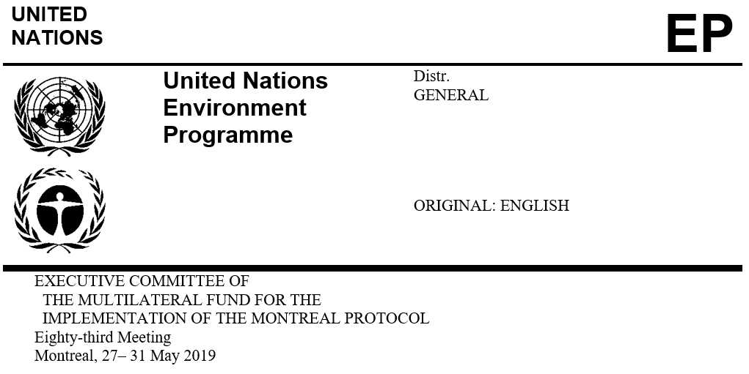

UNEP/OzL.Pro/ExCom/83/11/Add.2
10 May 2019

Addendum

REPORTS ON PROJECTS WITH SPECIFIC REPORTING REQUIREMENTS

This document is issued to:
- Add information from the Government of China on its monitoring, reporting, verification and enforcement systems. That information is appended to the present document, as submitted.

