UNITED  NATIONS |  | EP
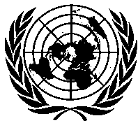 | United Nations  Environment  Programme | Distr.  GENERAL  UNEP/OzL.Pro/ExCom/80/29/Corr.1  17 October 2017  ORIGINAL: ENGLISH
EXECUTIVE COMMITTEE OF
THE MULTILATERAL FUND FOR THE
IMPLEMENTATION OF THE MONTREAL PROTOCOL
Eightieth Meeting
Montreal, 13-17 November 2017

Corrigendum

2018 core unit costs for UNDP, UNIDO and the World Bank

This document is being issued to:

In paragraph 40(b), remove the words “for which it is requesting reimbursement” in the last sentence.

