UNITED  NATIONS |  | EP
 | United Nations  Environment  Programme | Distr.  GENERAL  UNEP/OzL.Pro/ExCom/80/7  25 October 2017  ORIGINAL: ENGLISH
EXECUTIVE COMMITTEE OF
THE MULTILATERAL FUND FOR THE
IMPLEMENTATION OF THE MONTREAL PROTOCOL
Eightieth Meeting
Montreal, 13-17 November 2017

APPROVED 2017, REVISED 2018, 2019 AND PROPOSED 2020 BUDGETS OF THE FUND SECRETARIAT

This document presents the approved 2017, revised 2018 and 2019 and proposed 2020 budgets of the Fund Secretariat.

The document consists of the following sections:

- Approved 2017
- Revised 2018 and 2019 budget
- Proposed 2020 budget
- Recommendations

The approved 2017, revised 2018 and 2019, and proposed 2020 budgets of the Fund Secretariat are presented in Annex I of the present document.

Approved 2017

The Treasurer has submitted the final 2016 accounts to the 80th meeting. Schedule 1.3 (actual expenses of the Secretariat budget in 2016) of the document indicates an unspent balance of US $1,451,566; however, an additional US $62,808 spent in 2016 had not been recorded as an expense in 2016. Accordingly, it will be reallocated to the approved 2017 budget. Further to this adjustment, the unspent balance of US $1,388,758 (i.e. US $1,345,650 under the Secretariat budget and US $43,108 from the Senior Monitoring and Evaluation Officer budget) will be returned to the Multilateral Fund at the
80th meeting.

Revised 2018 and 2019 budgets

At the 77th meeting, the Executive Committee considered the document on the approved 2015, 2016, 2017 and 2018, and proposed 2019 budgets of the Fund Secretariat. Further to a discussion, the Executive Committee decided to increase the funding of the revised 2017 and 2018 budgets and the proposed 2019 budget to include one additional meeting of the Executive Committee on those years (at a cost of US $355,800 for the meeting and US $92,800 for other meeting-related costs).

At the 79th meeting, during the discussion on the dates and venues of the 81st and 82nd meetings (under agenda item 13: Other matters), there was general agreement that the scenario of two meetings per year was preferable, and that a meeting could be extended by one day, if required, for the purposes of consultations. Accordingly, the Executive Committee decided to hold only two meetings in 2018.

Based on the discussions at the 79th meeting, the Secretariat has reduced the funding of the revised 2018 and 2019 budgets approved under decision 77/63, to make provision for two meetings of the Executive Committee per year rather than three.

Annex I of the present document presents the revised 2018 and 2019 to make provision for two meetings a year instead of three (i.e., US $9,400 under temporary assistance (BL 1335), US $355,800 under conference service (BL 1336), US $75,000 under meeting participants (BL 3302), and US $8,400 under hospitality (BL 5401)) and adjustment to BL 1111 to reflect the correct funding level (i.e., US $20,166 and US $24,823 in 2018 and 2019, respectively).

Proposed 2020 budget

The proposed 2020 budget is based on the 2019 revised budget. It makes provision for two meetings of the Executive Committee, and continue to apply a 3 per cent inflation rate to staff cost only.

Recommendations

The Executive Committee may wish

- To note:

- The document on approved 2017, revised 2018 and 2019, and proposed 2020 budgets of the Fund Secretariat contained in UNEP/OzL.Pro/ExCom/80/7;

- That US $62,802 expenditures not recorded in the 2016 accounts had been reallocated to the 2017 approved budget;

- The return of US $1,388,758 (US $1,345,650 from the approved 2016 budget for the Secretariat and US $43,108 from the approved 2016 budget for
the Senior Monitoring and Evaluation Officer) to the Multilateral Fund at the
80th meeting;

- To approve:

    - The revised 2018 and 2019 budget amounting to US $7,402,419 and US $7,540,205 respectively; and

    - The proposed 2020 budget of US $7,682,125 based on the revised 2019 budget with two meetings of the Executive Committee, and a 3 per cent increase in staff cost.

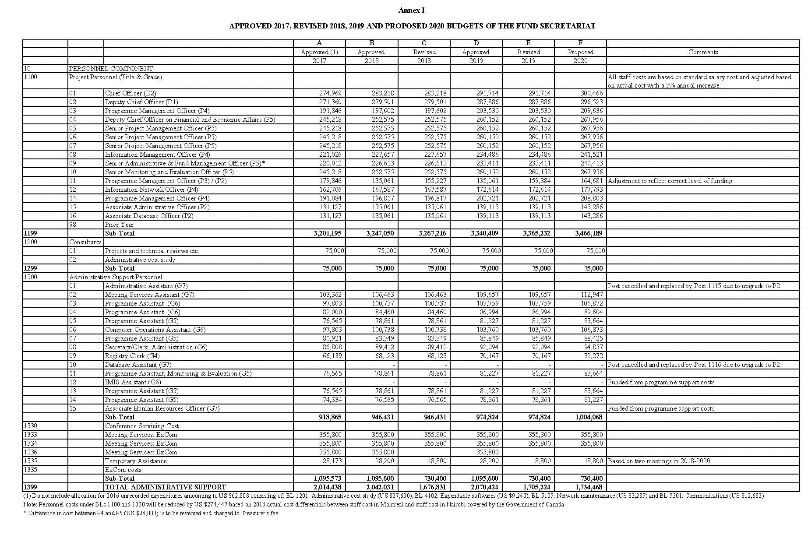
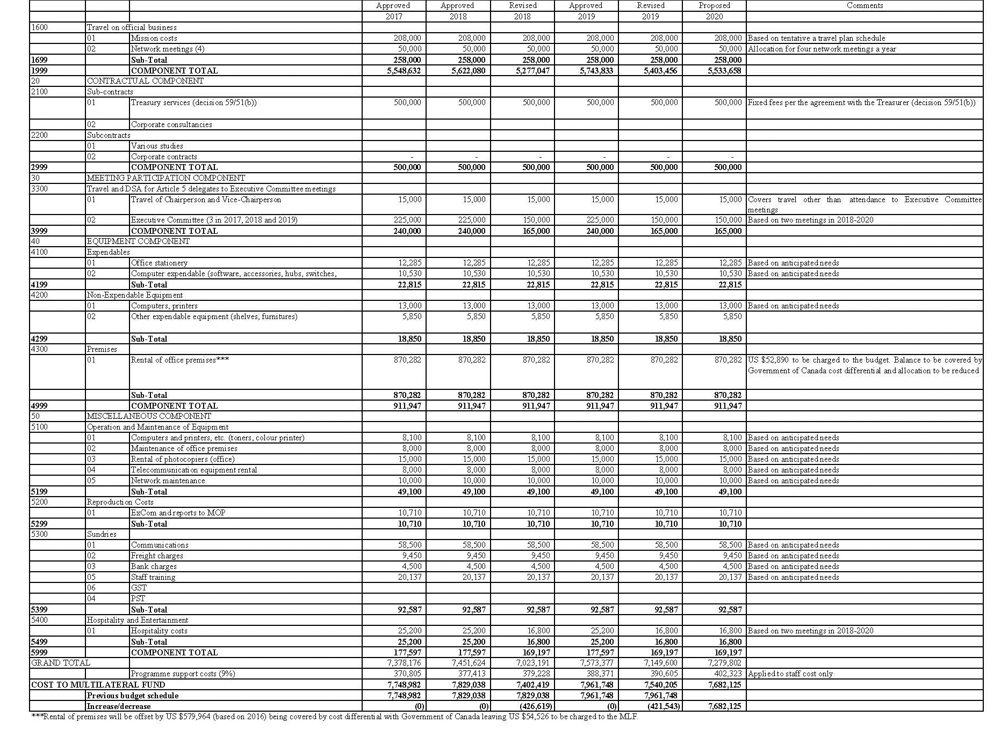

Document UNEP/OzL.Pro/ExCom/80/5 reflects the actual expenditures in 2016.
Pages 3 to 5 of Annex I of document UNEP/OzL.Pro/ExCom/80/5 presents expenses by budget line. A breakdown of the unrecorded expenditures is provided in Column E of the Annex.

