UNITED  NATIONS |  | EP
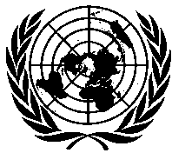 | United Nations  Environment  Programme | Distr.  GENERAL  UNEP/OzL.Pro/ExCom/79/5/Corr.1  19 June 2017  ORIGINAL: ENGLISH
EXECUTIVE COMMITTEE OF
THE MULTILATERAL FUND FOR THE
IMPLEMENTATION OF THE MONTREAL PROTOCOL
Seventy-ninth Meeting
Bangkok, 3-7 July 2017

Corrigendum

COUNTRY PROGRAMME DATA AND PROSPECTS FOR COMPLIANCE

This document is being issued to:
- Replace the row pertaining to Montenegro in Annex II as follows:
Country | Source  *** | Year of latest consumption | Baseline (ODP t) | Latest consumption | % over freeze | % over 10% reduction | Control addressed by HPMPs
Montenegro | CP | 2016 | 0.80 | 0.62 | 0.0 | 0.0 | 35% by 2020

