UNITED  NATIONS |  | EP
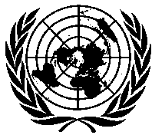 | United Nations  Environment  Programme | Distr.  GENERAL  UNEP/OzL.Pro/ExCom/78/10/Corr.1  3 April 2017  ORIGINAL: ENGLISH
EXECUTIVE COMMITTEE OF
THE MULTILATERAL FUND FOR THE
IMPLEMENTATION OF THE MONTREAL PROTOCOL
Seventy- eighth Meeting
Montreal, 4-7 April 2017

Corrigendum

DRAFT PROCEDURES FOR ARTICLE 5 COUNTRIES THAT HAVE HFC CONSUMPTION BASELINE YEARS FROM 2020 TO 2022 IN ACCESSING ADDITIONAL CONTRIBUTIONS FOR ENABLING ACTIVITIES

This document is being issued to:
- In Table 1, replace 17 with 16 under column “Number of countries” and 3,613,350 with 3,400,800 under column “Total” in row “>90.0 < 1,150.”
- In Table 1, replace 18,377,400 with 18,164,850 in row “Total” and in paragraph 13.
- Replace US $8,622,600 with US $8,835,150 in paragraphs 13 and 16.

